# **Laravel Templating Layouts**

Doing Templates for Dynamic Contents

## **Overview**

Laravel has its own templating part so its easy for us to edit and add dynamic section or contents we want to add to the sitewide.

## **Layout Template Strings**

* **@extends()**
* **@include()**
* **@yield()**
* **@section() @endsection**
* **@hasSection**

### @extends()

It extends the layout file where the @yields() is placed. In My case I created a folder layout and create file “**app.blade.php**”

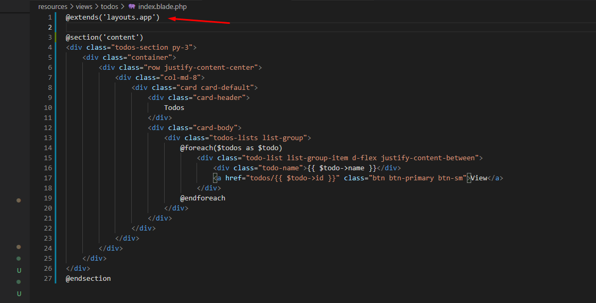

### @include()

It the same in inlucde() php. It include php file like in my header. I created **header.blade.php**  and include it to my layout. See below

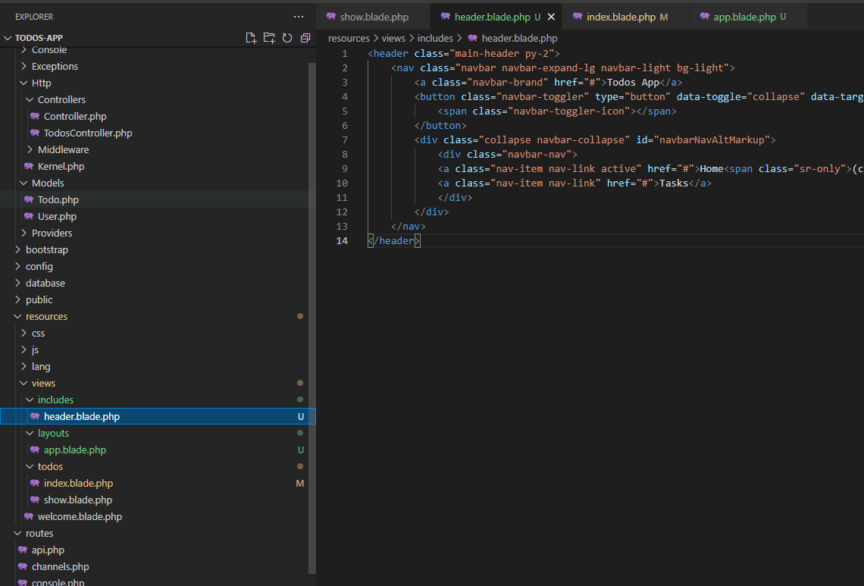

To include it you just need to add it in your layout file or anywhere. Same in my case:

@include('includes.header') <!-- path of your folder.filename -->

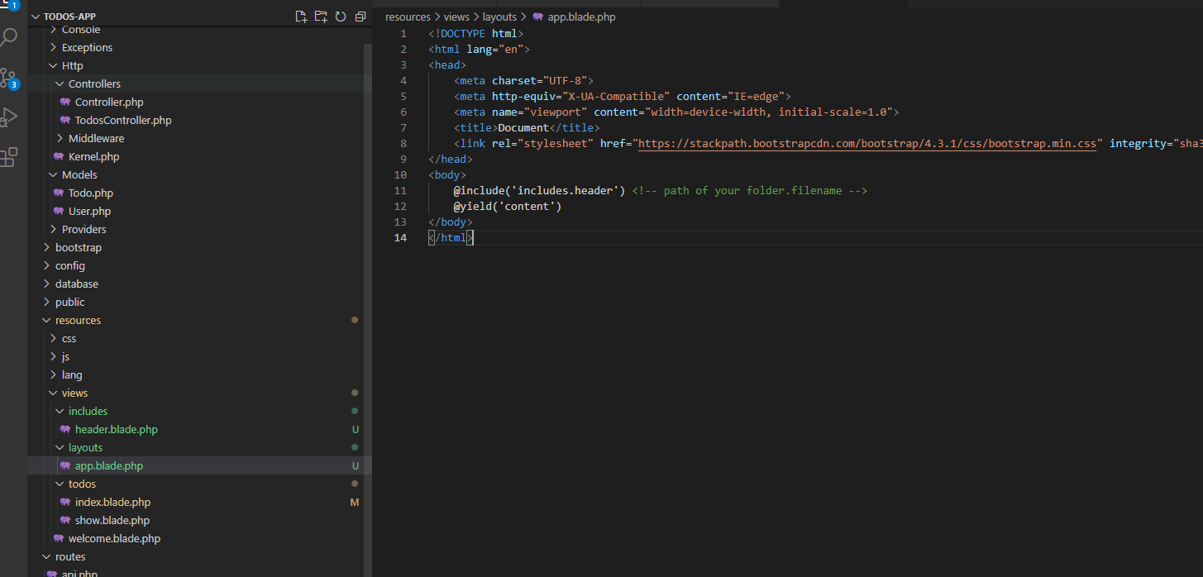

### @yield()

It gives way to @section to add in the template layout. These two is connected for Laravel templating content.

@yield('content') <!-- gives a space to @section(content) to echo here -->

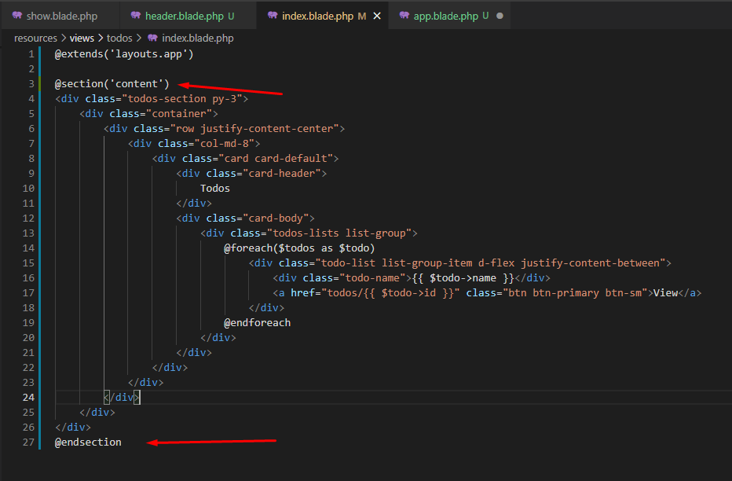

### @section()

At this template part you add the html contents you want to place to your main template in the line of @yield. In my case above we use the **yield(content) and**

@section(content)

    <!-- Code here -->

@endsection

Note you need to extends the layout file first to yield it there:

@extends('layouts.app')

### @hasSection()

This template string checks if the section of current view exists or not. Check the below conditions.

<

title>

        @hasSection('page-title')

            @yield('page-title') <!-- Dynamic Value per View if exist -->

        @else

            Todo App <!-- Default/Static Title value -->

        @endif

 </title>